Unit 5: Photosynthesis (Ch.4; pgs. 102-106)

1. What is photosynthesis: __Plants use the energy of sunlight to conert H₂O and CO₂ in sugars and release O₂___

2. Identify the organelle (cell organ) where photosynthesis occurs _chloroplasts_

3. A pigment is a molecule that absorbs light energy. What is the main pigment that absorbs light energy for
photosynthesis? _chlorophyll___

4. Inside the chloroplasts are photosynthetic membranes called __thylakoids____where the
machinery for photosynthesis occurs.

5. What is the role of chlorophyll in the process of photosynthesis? Absorbs light very efficiently by transferring light
energy to it’s electrons which powers photosynthesis.

6. Complete the equation for Photosynthesis:

Light energy
_CO₂_ (gas) + __H₂O___ (liquid) → → → → __C₆H₁₂O₆___ (type of chemical energy) + __O₂___(gas)

7. Circle the reactants & Box the products in the above chemical reaction
8. The process of photosynthesis is done by Plants/ Animals/ or BOTH (circle one) PLANTS

Steps of Photosynthesis: Review pgs. 105-106 and parts 1 & 2 to help complete the summary below.

Part 1: Light dependent reactions: Inside the chloroplast are the thylokoid membranes. Light reacts with the pigment
Chlorophyll. To make high energy compounds like ATP and release oxygen gas.

Part 2: Light-independent reaction (Calvin cycle): Inside the stroma (liquid) of the chloroplasts, high energy
compounds along with water and carbon dioxide are used to make simple sugars (C₆H₁₂O₆ or glucose)

The light reaction occurs in the __thylakoid __ membranes. Light reacts/ is absorbed by the pigment
_chlorophyll__. High energy compounds like, _ATP__ are made and _oxygen gas___ is
released. The light-independent reaction occurs in the liquid portion of the chloroplast called the __stroma___.
The high energy compounds made during part 1, along with _carbon dioxide _& water__ are used to make sugar. The name of the sugar molecule made during photosynthesis is called __glucose___, which is this type of organic compound __carbohydrate_____. During photosynthesis there is a transformation of energy. The energy used is __light_______ and the energy made is ___chemical (food)_______.
Complete the assigned interactive assigned in Google Classroom; A Model of Photosynthesis.
You need to complete this interactive review, AND for slide #3, use your answer the fill in the following tables:

LIGHT-DEPENDENT REACTION
Inputs: Light energy and Water | Outputs: Oxygen (ATP and NADPH)
Structure(s) responsible: Thylakoids | XXXXXXXXXXXXXXXXXXXXXXXXXXXXXXXXXXXXXXXXXX

LIGHT-INDEPENDENT REACTION
Inputs: carbon dioxide (ATP/NADPH) | Outputs: Glucose (high-energy sugars)
Structure(s) responsible: Stroma | XXXXXXXXXXXXXXXXXXXXXXXXXXXXXXXXXXXXXXXXXXXX

Model: Use your previous knowledge & figure 4-6 (pg.106), along with the following terms to label the following diagrams
(you may use more than once) Water; Oxygen; Carbon dioxide; Glucose (C₆H₁₂O₆); Sunlight
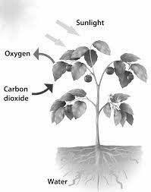
Sunlight

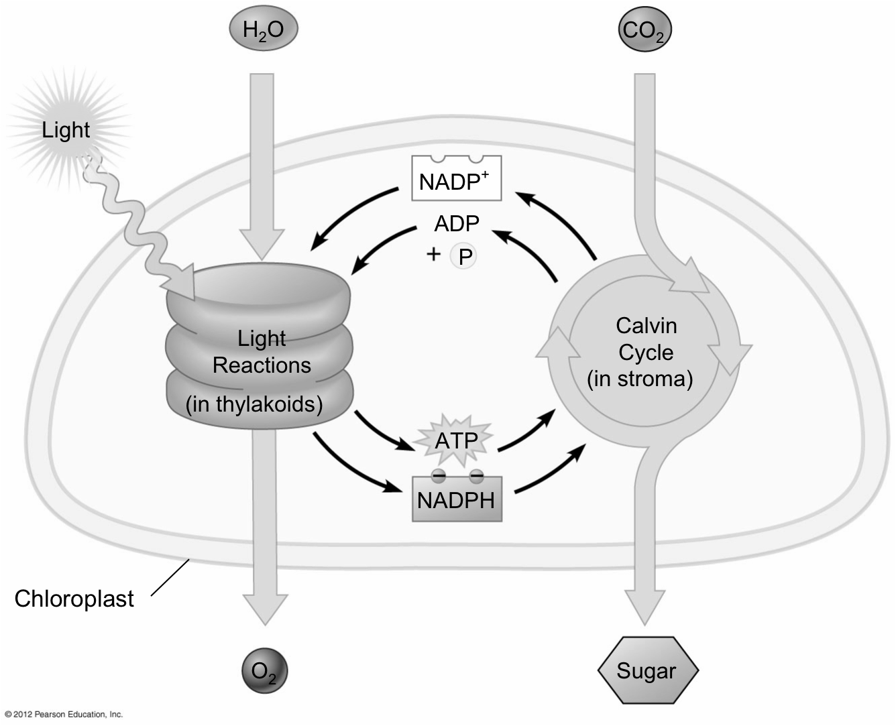
Water
Carbon Dioxide

Oxygen
Glucose

1. Predict: Do you think photosynthesis uses enzymes? _Yes___ Explain your reasoning __photosynthesis is a
biological reaction and enzymes speed up reactions ______

Read pg.112 and answer the following 2 questions.
2. What are the 3 factors that can affect the rate of chemical reactions that take place in photosynthesis.
Temperature, light intensity, and the availability of water.
3. Assuming there is enough light and water for photosynthesis to occur, EXPLAIN why a temperature between
0ºC and 35ºC is still important.
Enzymes make photosynthesis possible and those enzymes work best between these temperatures. If the
temperature is too low or too high, enzymes will work too slowly and will affect the rate of photosynthesis.

Predict & Explain: In a laboratory experiment, a plant receives sunlight and water, but not CO₂. Predict what happens to the plant and EXPLAIN your predictions based on your knowledge of light dependent and independent reactions.
The plant would die. The light-independent reactions would stop working as no CO₂ is taken up which means the light-dependent reactions would back up and stop working. No high energy sugars would be made.

